Linux Command Tasks Submission
Project Title: Linux Command Line Exercises
Your Name: Kunal M Waghmare
Date: 12/11/2025

1. Creating and Renaming Files/Directories
Command/Action:
mkdir test_dir
cd test_dir
touch example.txt
mv example.txt renamed_example.txt
Screenshot:
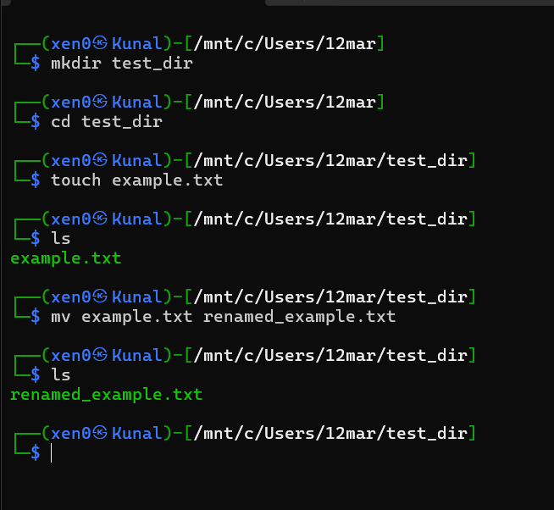
Explanation:
- Created a directory named test_dir.
- Inside it, an empty file example.txt was created.
- The file was renamed to renamed_example.txt using mv.
- This demonstrates basic file and directory management in Linux.

2. Viewing File Contents
Command/Action:
cat /etc/passwd
head -n 5 /etc/passwd
tail -n 5 /etc/passwd
Screenshot:
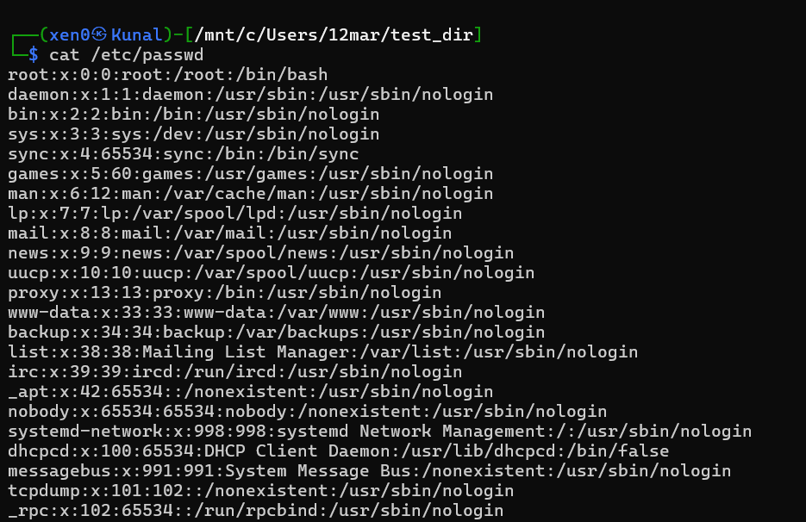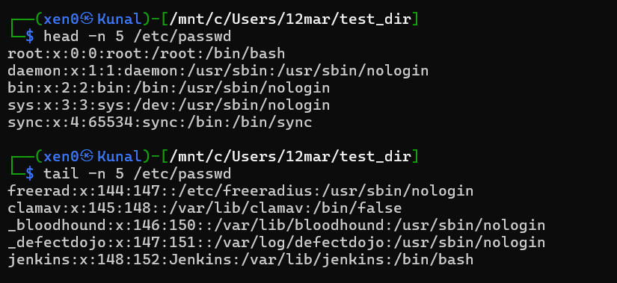
Explanation:
- cat displays the full contents of /etc/passwd.
- head -n 5 shows only the first 5 lines.
- tail -n 5 shows only the last 5 lines.
- Useful for quickly viewing parts of large files.

3. Searching for Patterns
Command/Action:
grep "root" /etc/passwd
Screenshot:
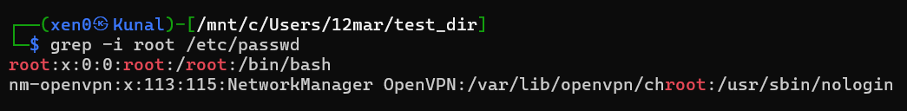
Explanation:
- grep searches for the word "root" in /etc/passwd.
- Displays all lines containing "root".
- Helpful for quickly finding specific entries in files.

4. Zipping and Unzipping
Command/Action:
zip -r test_dir.zip test_dir
unzip test_dir.zip -d unzipped_dir
Screenshot:
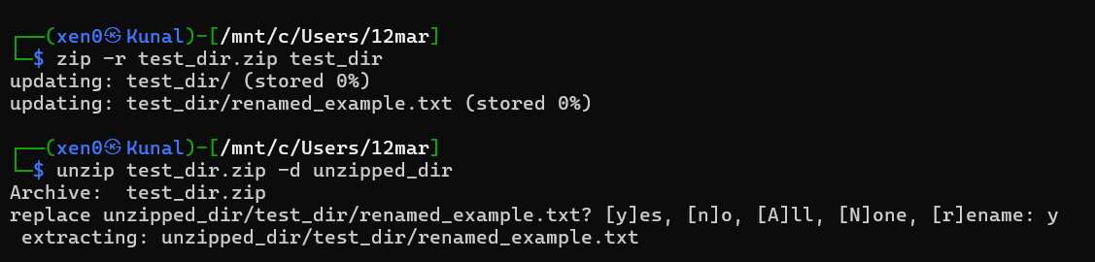
Explanation:
- zip -r compresses the directory test_dir into test_dir.zip.
- unzip extracts the contents into a new directory unzipped_dir.
- Demonstrates file compression and extraction in Linux.

5. Downloading Files
Command/Action:
wget https://example.com/sample.txt
Screenshot:
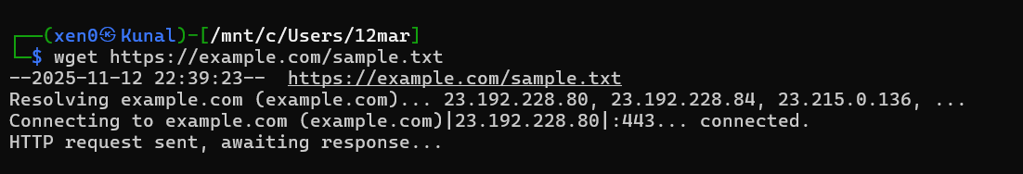
Explanation:
- wget downloads a file from a specified URL.
- Useful for fetching files directly from the internet to the terminal.

6. Changing Permissions
Command/Action:
touch secure.txt
chmod 444 secure.txt
Screenshot:
Explanation:
- Created a file secure.txt.
- chmod 444 sets read-only permissions for owner, group, and others.
- Demonstrates file permission management in Linux.

7. Working with Environment Variables
Command/Action:
export MY_VAR="Hello, Linux!"
echo $MY_VAR
Screenshot:
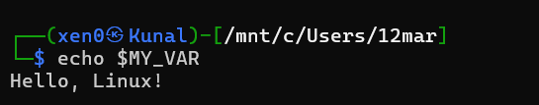
Explanation:
- export creates a new environment variable MY_VAR.
- echo $MY_VAR confirms the value is set.
- Useful for storing temporary session variables.

GitHub Repository Link
[https://github.com/kunal-1207]

